Evaluation of POs and Cos

2022-23

- Outcome Attainment Analysis
- Methodology for CO to PO/PSO Mapping
- Methodology for CO attainment evaluation
- Preparation of POs, PSOs & Cos
- Feedback from Students
- Indirect CO attainment
- CO- PO/PSO mapping
- Summary of PO/PSO attainment

Outcome Attainment Analysis

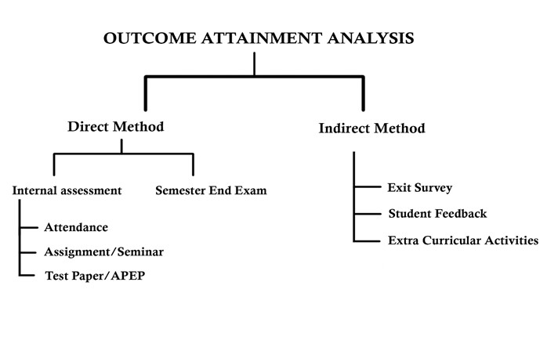

2.Methodology for CO to PO/PSO Mapping

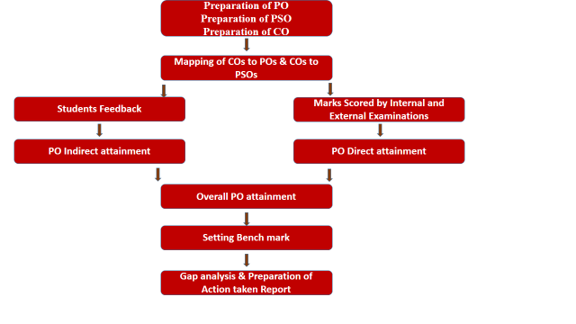

3.Methodology for CO attainment evaluation

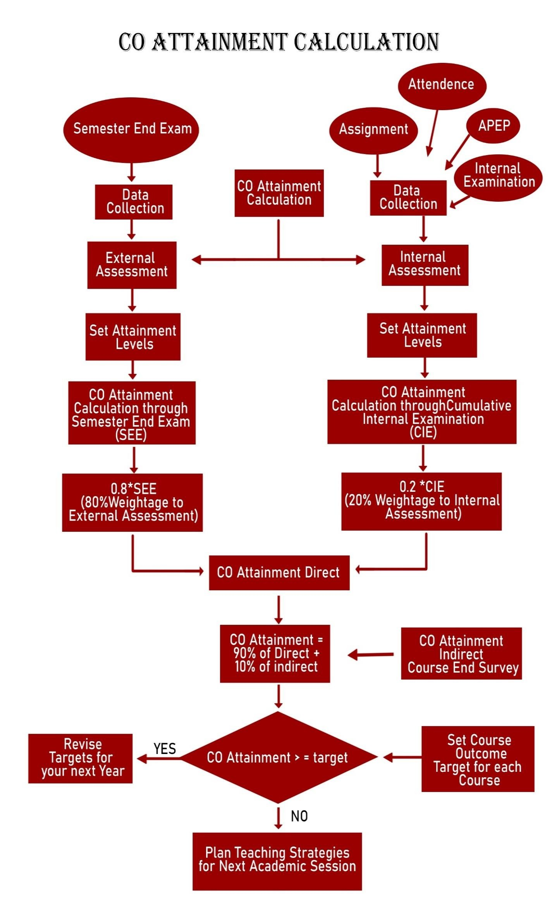
hfjksddsfdfsjkjj

4. preparation of Cos and Pos
“Program Outcomes (POs) for B.Sc. Computer Science”
- PO1 - Disciplinary Knowledge: Apply the fundamental knowledge of Computer Science, Mathematics, and Electronics to solve real-world problems.
- PO2 - Problem Solving: Identify, analyse, and develop efficient solutions using appropriate algorithms, programming languages, and tools.
- PO3 - Modern Tool Usage: Utilize modern computing tools, software, and techniques effectively for software and hardware-based solutions.
- PO4 - Communication Skills: Communicate effectively using written, oral, and graphical modes, especially in documentation and presentation.
- PO5 - Ethics and Responsibility: Demonstrate ethical behaviour and professional responsibility in computing practice.
- PO6 - Teamwork and Leadership: Work effectively as an individual and as a member/leader in multidisciplinary teams.
- PO7 - Lifelong Learning: Recognize the need for and engage in lifelong learning through continual professional development.
- PO8 - Societal and Environmental Concern: Understand the societal, legal, and environmental issues related to computing technologies.
- PO9 - Project Management: Apply project management principles and practices to effectively carry out software or research projects.
- PO10 - Analytical and Critical Thinking: Use critical thinking and analytical reasoning for data analysis and decision-making in computing contexts.

Course Outcomes (COs)
TC003101 – Computer Fundamentals
- CO1: Understand the basic structure and functioning of computer systems and peripheral devices.
- CO2: Describe various number systems and perform conversions between them.
- CO3: Identify and explain input/output devices, memory units, and storage technologies.
- CO4: Understand the classification of software and system architecture.
- CO5: Gain knowledge of Internet fundamentals and common application software.

Course Outcomes (COs)
TC003102 – Digital Electronics
- CO1: Understand the fundamental concepts of number systems, Boolean algebra, and logic gates.
- CO2: Design and analyse combinational logic circuits like adders, subtractors, multiplexers, and decoders.
- CO3: Study and implement sequential circuits such as flip-flops, counters, and registers.
- CO4: Understand the working of basic digital components like encoders and decoders.
- CO5: Use Karnaugh Maps for logic simplification.

Course Outcomes (COs)
TC003103 – Operating System-I
- CO1: Understand the basic concepts and functions of operating systems.
- CO2: Learn about process management, threads, and CPU scheduling.
- CO3: Describe synchronization, deadlock, and inter-process communication.
- CO4: Understand memory management techniques such as paging and segmentation.
- CO5: Explore file systems and device management principles.

Course Outcomes (COs)
TC003104 – Programming in C
- CO1: Understand the fundamentals of C programming and structure of C programs.
- CO2: Use data types, operators, control structures, and loops in C.
- CO3: Implement user-defined functions and recursion.
- CO4: Work with arrays, strings, structures, and unions.
- CO5: Perform file handling operations and dynamic memory allocation in C.

Course Outcomes (COs)
TC003105 – Mathematical Foundation (M-1)
- CO1: Understand sets, relations, and functions in mathematical context.
- CO2: Apply concepts of matrices and determinants in computer applications.
- CO3: Solve systems of linear equations using various methods.
- CO4: Understand the concepts of limits, continuity, and differentiation.
- CO5: Apply calculus in computing-based problem solving.

Course Outcomes (COs)
TC003106 – Programming Methodology
- CO1: Understand problem-solving strategies and flowcharting techniques.
- CO2: Learn about software development life cycle (SDLC).
- CO3: Analyze algorithms for time and space complexity.
- CO4: Study structured and modular programming concepts.
- CO5: Develop structured solutions for simple programming problems.

Course Outcomes (COs)
TC003107 – English Communication Skill (Linguistic Approach)
- CO1: Improve vocabulary, grammar, and sentence structure.
- CO2: Develop listening, speaking, reading, and writing skills.
- CO3: Understand the basics of linguistic approaches to language learning.
- CO4: Enhance communication skills for academic and professional purposes.
- CO5: Participate in group discussions, presentations, and interviews with confidence.

Course Outcomes (COs)
TC003108 – Marathi
- CO1: Understand the fundamentals of Marathi grammar and syntax.
- CO2: Improve Marathi vocabulary and comprehension.
- CO3: Interpret literary texts and cultural expressions in Marathi.
- CO4: Develop writing skills for academic and formal purposes.
- CO5: Enhance communication skills in Marathi for day-to-day and professional use.

Program Outcomes (POs) – B.Sc. Computer Science
- PO1: Core Knowledge – Understand and apply the core principles of Computer Science, Mathematics, and Electronics.
- PO2: Technical Proficiency – Demonstrate the ability to develop algorithms, write programs, and use appropriate software tools.
- PO3: Problem Analysis – Analyze real-world problems and devise efficient computer-based solutions.
- PO4: Research and Innovation – Apply research-based knowledge and methods including design, analysis, and interpretation of data.
- PO5: Modern Tool Usage – Use modern IT tools and software development environments efficiently.
- PO6: Communication – Communicate effectively in both technical and non-technical environments.
- PO7: Teamwork – Work as an individual and collaboratively in a team to accomplish a common goal.
- PO8: Ethics and Sustainability – Understand professional, ethical, and social responsibilities in computing practices.
- PO9: Lifelong Learning – Engage in continuous learning and upskilling in the fast-evolving field of computer science.
- PO10: Project Management – Apply project and time management skills in academic and professional projects.
- PO1: Core Knowledge – Understand and apply the core principles of Computer Science, Mathematics, and Electronics.
- PO2: Technical Proficiency – Demonstrate the ability to develop algorithms, write programs, and use appropriate software tools.
- PO3: Problem Analysis – Analyze real-world problems and devise efficient computer-based solutions.
- PO4: Research and Innovation – Apply research-based knowledge and methods including design, analysis, and interpretation of data.
- PO5: Modern Tool Usage – Use modern IT tools and software development environments efficiently.
- PO6: Communication – Communicate effectively in both technical and non-technical environments.
- PO7: Teamwork – Work as an individual and collaboratively in a team to accomplish a common goal.
- PO8: Ethics and Sustainability – Understand professional, ethical, and social responsibilities in computing practices.
- PO9: Lifelong Learning – Engage in continuous learning and upskilling in the fast-evolving field of computer science.
- PO10: Project Management – Apply project and time management skills in academic and professional projects.

Course Outcomes (COs) – Semester II
PC003201 – Lab Course Based on TC003101 (Computer Fundamentals)
- CO1: Operate different hardware components and peripheral devices.
- CO2: Perform conversions among number systems.
- CO3: Use application software tools like MS Word, Excel, and PowerPoint.
- CO4: Demonstrate the basics of internet usage and online tools.
- CO5: Apply system software knowledge through hands-on practice.

Course Outcomes (COs) – Semester II
TC003102 – Digital Electronics
- CO1: Understand number systems and perform logic simplification.
- CO2: Design combinational and sequential logic circuits.
- CO3: Work with flip-flops, counters, and registers.
- CO4: Analyze digital logic circuits using Boolean algebra.
- CO5: Use basic digital electronics in computing applications.

Course Outcomes (COs) – Semester II
TC003201 – Operating System II
- CO1: Explain advanced memory management techniques like paging and segmentation.
- CO2: Understand virtual memory, demand paging, and page replacement.
- CO3: Analyze file system architecture and allocation methods.
- CO4: Explore I/O system, buffering, spooling, and disk scheduling.
- CO5: Understand system security, protection mechanisms, and case studies on Linux/Windows OS.

Course Outcomes (COs) – Semester II
TC003202 – Programming in C++
- CO1: Understand the basic syntax and structure of C++ programs.
- CO2: Apply object-oriented programming principles: classes, objects, inheritance, and polymorphism.
- CO3: Use constructors, destructors, and operator overloading in programs.
- CO4: Implement file handling using C++ streams.
- CO5: Develop real-world applications using OOP concepts in C++.

Course Outcomes (COs) – Semester II
PC003202 – Lab Course Based on TC003103 (Operating System-I)
- CO1: Simulate basic process scheduling algorithms.
- CO2: Demonstrate inter-process communication techniques.
- CO3: Implement memory management schemes in simulation.
- CO4: Apply file and device management through UNIX/Linux commands.
- CO5: Use OS commands to explore file systems and system calls.

Course Outcomes (COs) – Semester II
TC003104 – Programming in C
- CO1: Develop structured programs using C language.
- CO2: Write C programs using arrays, strings, pointers, and functions.
- CO3: Implement structures and unions in real-time applications.
- CO4: Perform dynamic memory allocation using malloc and calloc.
- CO5: Apply file operations for data processing applications.

Course Outcomes (COs) – Semester II
TC003203 – Discrete Mathematics
- CO1: Understand the basics of logic, truth tables, and predicate logic.
- CO2: Solve problems involving sets, relations, and functions.
- CO3: Apply principles of counting, permutations, and combinations.
- CO4: Work with graphs, trees, and their applications in computer science.
- CO5: Understand recurrence relations and use them in algorithm analysis.

Course Outcomes (COs) – Semester II
TC003204 – Environmental Studies
- CO1: Understand the structure and functions of ecosystems.
- CO2: Identify natural resources and the need for their conservation.
- CO3: Analyze environmental pollution and its impact.
- CO4: Explore social issues related to the environment including sustainable development.
- CO5: Develop a sense of responsibility towards environmental conservation.

Course Outcomes (COs) – Semester II
PC003203 – Lab Course Based on TC003105 (Mathematical Foundation)
- CO1: Perform matrix operations using programming tools.
- CO2: Solve linear equations through various computational methods.
- CO3: Visualize and apply concepts of calculus using software.
- CO4: Use tools like MATLAB/Scilab/Excel for mathematical modeling.
- CO5: Apply mathematical logic and set theory to programming problems.

Course Outcomes (COs) – Semester II
TC003106 – Programming Methodology
- CO1: Understand the software development life cycle and problem-solving techniques.
- CO2: Design algorithms using flowcharts and pseudo-code.
- CO3: Analyze and convert algorithms into executable programs.
- CO4: Apply structured programming principles in small applications.
- CO5: Demonstrate debugging and testing methods effectively.

Course Outcomes (COs) – Semester II
TC003205 – Numerical Methods (Mathematics–II)
- CO1: Solve algebraic and transcendental equations using iterative methods.
- CO2: Apply numerical techniques for interpolation and curve fitting.
- CO3: Perform numerical differentiation and integration.
- CO4: Solve ordinary differential equations using Euler’s and Runge-Kutta methods.
- CO5: Implement numerical methods using C/C++/Python.

Course Outcomes (COs) – Semester II
TC003206 – Database Management System (DBMS)
- CO1: Understand basic concepts of DBMS and data models.
- CO2: Design and implement relational databases using ER models.
- CO3: Use SQL for data definition and data manipulation.
- CO4: Normalize databases using functional dependencies and normalization techniques.
- CO5: Understand transaction management, concurrency control, and recovery techniques.

Course Outcomes (COs) – Semester II
TC003201 – Data Structures
- CO1: Understand the basic concepts and importance of data structures.
- CO2: Implement linear data structures like arrays, stacks, queues, and linked lists.
- CO3: Apply non-linear data structures like trees and graphs.
- CO4: Perform searching and sorting using appropriate algorithms.
- CO5: Analyze time and space complexity for different data structures.

🔹

Course Outcomes (COs) – Semester II
TC003202 – 8086 Microprocessor
- CO1: Understand the architecture and instruction set of 8086 microprocessor.
- CO2: Write assembly language programs using 8086 instructions.
- CO3: Interface peripheral devices using 8086 microprocessor.
- CO4: Understand memory segmentation, addressing modes, and interrupts.
- CO5: Apply 8086 in basic computing hardware applications.

Course Outcomes (COs) – Semester II
TC003203 – Operating System-II
- CO1: Describe advanced memory management schemes like segmentation and paging.
- CO2: Discuss file system implementation and directory structures.
- CO3: Understand disk scheduling algorithms and I/O management.
- CO4: Explore system protection and security mechanisms.
- CO5: Compare performance features of Unix/Linux and Windows OS.

Course Outcomes (COs) – Semester II
TC003204 – Advanced Programming in C
- CO1: Understand advanced concepts like pointers to pointers, dynamic memory, and linked data structures.
- CO2: Implement file handling, command-line arguments, and error handling.
- CO3: Apply recursion, memory allocation, and bitwise operations.
- CO4: Develop modular programming using functions and header files.
- CO5: Build real-time system-level applications in C.

Course Outcomes (COs) – Semester II
TC003207 – English Communication Skill (Soft Skill Development)
- CO1: Improve English language proficiency for professional settings.
- CO2: Develop soft skills including body language, teamwork, and etiquette.
- CO3: Practice group discussions, public speaking, and interview skills.
- CO4: Understand resume writing, business communication, and report writing.
- CO5: Demonstrate confident communication in academic and corporate environments.

Course Outcomes (COs) – Semester II
TC003208 – Marathi
- CO1: Understand the literary richness of Marathi through prose and poetry.
- CO2: Develop comprehension and analytical skills in Marathi language.
- CO3: Use Marathi for effective communication in personal and professional settings.
- CO4: Practice creative writing, translation, and report writing in Marathi.
- CO5: Appreciate the cultural and social aspects embedded in Marathi literature.

Program Outcomes (POs) – B.Sc. Computer Science
Semester IIIrd
- PO1: Core Knowledge – Acquire foundational and advanced knowledge in computer science, programming, databases, operating systems, and web development.
- PO2: Technical Proficiency – Develop the ability to apply programming techniques, data structures, and computational tools to solve problems.
- PO3: Problem Solving Skills – Analyse real-world problems and design effective computer-based solutions.
- PO4: Communication – Develop written and oral communication skills in both technical and general environments.
- PO5: Teamwork and Ethics – Work effectively in teams while demonstrating ethical and professional behaviour.
- PO6: Modern Tool Usage – Utilize modern tools and software to enhance productivity and application development.
- PO7: Lifelong Learning – Recognize the need for continuous learning and the ability to engage in technological advancements.

Course Outcomes (COs) – Semester III
🔹 TC003301 – Object Oriented Programming Using C++
- CO1: Understand the basic principles of Object-Oriented Programming (OOP).
- CO2: Implement classes and objects using C++.
- CO3: Apply concepts such as inheritance, polymorphism, encapsulation, and abstraction.
- CO4: Use constructors, destructors, operator overloading, and file handling in C++.
- CO5: Develop C++ programs for real-world applications using OOP principles.

Course Outcomes (COs) – Semester III
🔹 TC003302 – Relational Database Management System (RDBMS)
- CO1: Understand the architecture and principles of relational database systems.
- CO2: Apply SQL commands for data definition, manipulation, and querying.
- CO3: Design normalized relational database schemas.
- CO4: Understand concepts like transactions, concurrency, and recovery in RDBMS.
- CO5: Use PL/SQL to implement stored procedures, triggers, and cursors.

Course Outcomes (COs) – Semester III

TC003303 – Linux Operating System
- CO1: Understand the structure and features of Linux OS.
- CO2: Use basic and advanced Linux commands for file and system management.
- CO3: Write and execute shell scripts.
- CO4: Manage user accounts, permissions, and process controls in Linux.
- CO5: Understand Linux file system, boot process, and system administration tasks.

Course Outcomes (COs) – Semester III
TC003304 – Advanced Data Structure
- CO1: Understand and implement advanced data structures like AVL trees, B-trees, and heaps.
- CO2: Apply graph algorithms (BFS, DFS, shortest path, MST).
- CO3: Analyze the performance and complexity of data structures and algorithms.
- CO4: Solve real-time problems using appropriate data structures.
- CO5: Implement priority queues, hashing, and threaded trees.

Course Outcomes (COs) – Semester III
TC003305 – Computational Statistics Using R
- CO1: Understand basic statistical concepts and data types.
- CO2: Use R language for data manipulation and visualization.
- CO3: Perform descriptive statistics and inferential statistics using R.
- CO4: Apply correlation, regression, and hypothesis testing in R.
- CO5: Analyse and interpret data sets using statistical packages in R.

Course Outcomes (COs) – Semester III
TC003306 – Web Fundamental
- CO1: Understand the architecture of the web and internet protocols.
- CO2: Design basic web pages using HTML and CSS.
- CO3: Use client-side scripting languages like JavaScript for interactivity.
- CO4: Understand responsive design and introduction to Bootstrap.
- CO5: Develop simple front-end web applications.

Course Outcomes (COs) – Semester III
TC003307 – Communication Skill in English–III
- CO1: Enhance communication and presentation skills in academic and professional contexts.
- CO2: Practice oral skills including group discussions and interviews.
- CO3: Improve business correspondence skills (emails, reports, proposals).
- CO4: Develop interpersonal communication, negotiation, and leadership abilities.
- CO5: Build confidence in public speaking and soft skills.

Course Outcomes (COs) – Semester III
TC003308 – Marathi
- CO1: Understand various forms of Marathi literature and grammar.
- CO2: Develop creative and formal writing skills in Marathi.
- CO3: Analyse and interpret literary texts.
- CO4: Use Marathi language effectively for official and cultural communication.
- CO5: Understand social, ethical, and human values through literature.

Course Outcomes (COs) – Semester III
TC003312 (A) – Office Automation
- CO1: Understand the basics of office productivity tools.
- CO2: Work efficiently with word processors (MS Word/LibreOffice Writer).
- CO3: Create and manage spreadsheets (MS Excel/LibreOffice Calc) with functions and formulas.
- CO4: Design impactful presentations (MS PowerPoint/LibreOffice Impress).
- CO5: Apply office tools for documentation, calculation, and communication in business settings.

Program Outcomes (POs) – B.Sc. Computer Science
- PO1: Technical Knowledge – Gain advanced theoretical and practical knowledge in computer science, especially in programming, graphics, networks, and data analytics.
- PO2: Software Development Skills – Develop skills for designing and building software solutions using languages like Java, Python, and open-source tools.
- PO3: Application Proficiency – Apply computing knowledge in domains like mobile computing, web development, and visualization.
- PO4: Analytical Thinking – Strengthen analytical skills by applying statistics, data analysis, and problem-solving techniques.
- PO5: Communication & Presentation – Enhance communication, documentation, and presentation skills in English and Marathi.
- PO6: Digital Readiness – Be industry-ready with training in office tools, automation, and emerging technologies.
- PO7: Ethical & Social Responsibility – Develop a sense of responsibility, ethics, and appreciation for diverse cultures and languages.

Course Outcomes
Semester IV
PC003401 – Lab Course based on TC003301 (OOP in C++)
- Implement object-oriented programming concepts in real-life problems using C++.
- Apply class, object, constructor, and destructor effectively in program design.
- Perform function overloading, operator overloading, and inheritance through coding.
- Develop programs demonstrating runtime polymorphism and file handling.
- Solve computational problems using OOP principles in practical assignments.

Course Outcomes
Semester IV

TC003302 – Relational Database Management System
- Understand the concepts of relational database design and normalization.
- Perform SQL operations like DDL, DML, and DCL commands effectively.
- Apply joins, views, indexes, and transactions in database applications.
- Write PL/SQL procedures, functions, and triggers for complex queries.
- Develop database models for small-scale applications and manage relational integrity.

Course Outcomes
Semester IV
TC003401 – Core Java
- Understand and apply Java syntax, data types, and control structures.
- Implement OOP concepts such as inheritance, encapsulation, and polymorphism in Java.
- Develop GUI-based applications using AWT and Swing.
- Apply exception handling and multithreading techniques in Java applications.
- Create interactive and file-based programs using Java libraries and packages.

Course Outcomes
Semester IV
TC003402 – Computer Graphics
- Understand the fundamentals of computer graphics and its applications.
- Implement drawing algorithms like DDA and Bresenham’s for lines and circles.
- Apply 2D geometric transformations such as scaling, rotation, and translation.
- Demonstrate clipping algorithms and projection techniques.
- Develop simple graphical applications using standard graphics libraries.

Course Outcomes
Semester IV
PC003402 – Lab Course based on TC003303 (Linux OS)
- Use basic and advanced Linux commands for file and process management.
- Write and execute shell scripts to automate system tasks.
- Implement user management and permission-based tasks using shell scripting.
- Demonstrate file redirection, piping, and job control in practical exercises.
- Solve Linux-based practical problems using Bash scripting.

Course Outcomes
Semester IV

TC003304 – Advanced Data Structure
- Understand the concepts of advanced trees like AVL, B-tree, and Red-Black Tree.
- Apply heap and priority queue for efficient data access.
- Implement and analyze graph traversal algorithms like DFS and BFS.
- Solve real-world problems using advanced data structures and algorithms.
- Compare and evaluate data structures for time and space efficiency.

Course Outcomes
Semester IV

TC003403 – Basics of Android OS
- Understand Android architecture and application development process.
- Design and develop simple Android applications using XML and Java/Kotlin.
- Implement user interface components and handle UI events.
- Use intents, activities, and fragments in Android development.
- Work with data storage options and debug Android applications effectively.

Course Outcomes
Semester IV
TC003404 – Computer Networks
- Understand network models, architecture, and communication protocols.
- Describe transmission media, switching techniques, and network devices.
- Analyze IP addressing, subnetting, and routing techniques.
- Explain transport layer protocols like TCP and UDP.
- Understand network security issues and basics of encryption.

Course Outcomes
Semester IV

PC003403 – Lab Course based on TC003305 (Statistics Using R)
- Use R programming for basic statistical computation and data analysis.
- Apply statistical techniques such as mean, median, mode, and standard deviation.
- Perform data visualization using R libraries (e.g., ggplot2).
- Implement correlation, regression, and hypothesis testing in R.
- Analyze real-time datasets and draw meaningful conclusions using R.

Course Outcomes
Semester IV
TC003306 – Web Fundamentals
- Understand and apply HTML5 elements to build structured web pages.
- Use CSS3 to style and format web content effectively.
- Implement interactivity using JavaScript for client-side scripting.
- Develop responsive web designs using frameworks like Bootstrap.
- Create dynamic and user-friendly web interfaces.

Course Outcomes
Semester IV
TC003405 – Data Analytics
- Understand the basic concepts, tools, and stages in the data analytics life cycle.
- Apply data preprocessing techniques to clean and transform datasets.
- Use statistical methods for data summarization and inference.
- Implement classification, clustering, and visualization techniques.
- Analyze datasets using tools like R or Python for real-world problems.

Course Outcomes
Semester IV

TC003406 – Open Source Web Application Development
- Understand the LAMP/WAMP stack and its role in web development.
- Create dynamic websites using HTML, CSS, JavaScript, PHP, and MySQL.
- Implement CRUD operations and form validations using PHP.
- Use open-source tools and frameworks for application development.
- Build modular and interactive applications following the MVC pattern.

Course Outcomes
Semester IV

TC003407 – Communication Skills in English–IV
- Improve professional writing through resumes, cover letters, and emails.
- Participate in mock interviews, debates, and group discussions confidently.
- Demonstrate verbal and non-verbal communication skills in various contexts.
- Use appropriate vocabulary and tone in business communication.
- Apply soft skills such as teamwork, leadership, and time management effectively.

Course Outcomes
Semester IV
TC003408 – Marathi
- Understand and appreciate modern Marathi prose and poetry.
- Use Marathi language effectively for communication and academic writing.
- Develop analytical and interpretative skills through literary study.
- Write essays, reports, and letters in formal Marathi.
- Explore cultural values and contemporary themes through Marathi literature.

Course Outcomes
Semester IV
TC003412 (C) – Basic Python Programming
- Understand Python syntax, operators, and control flow constructs.
- Use built-in data structures like lists, tuples, and dictionaries.
- Write modular programs using functions and recursion.
- Handle file I/O and exceptions in Python programs.
- Develop basic applications using Python programming logic.

Program Outcomes (POs) for B.Sc. (Computer Science)
- Scientific Knowledge: Apply knowledge of computing fundamentals, mathematics, and computer science to solve real-world problems.
- Problem Analysis: Identify, formulate, and analyze computational problems to derive logical conclusions.
- Programming Skills: Use modern tools, programming techniques, and data structures to develop reliable software solutions.
- Design and Development: Design and implement solutions with appropriate software and hardware integration.
- Communication: Communicate effectively on technical topics with peers and society at large through presentations, reports, and documentation.
- Ethics and Responsibility: Understand and commit to professional ethics, cyber laws, and social responsibility in the computing profession.
- Teamwork and Leadership: Function effectively as an individual and in multidisciplinary teams.
- Lifelong Learning: Recognize the need for and engage in lifelong learning to keep pace with technological advancement.
- Project Management: Apply management principles in team projects and demonstrate entrepreneurial and leadership skills.

Course Outcomes (COs)
Semester V
TC003501 – Advanced Java
- Understand and apply the concept of multithreading and exception handling in Java.
- Create GUI applications using AWT and Swing components.
- Develop network-based applications using Java networking APIs.
- Work with Java I/O streams, serialization, and JDBC connectivity.
- Build small-scale enterprise-level applications using Java frameworks.

Course Outcomes (COs)
Semester V
TC003507 – Advanced PHP
- Understand the architecture of dynamic websites and advanced PHP syntax.
- Develop secure and interactive web applications using sessions, cookies, and file handling.
- Integrate MySQL database with PHP for CRUD operations.
- Implement MVC architecture using frameworks like Laravel (or core PHP concepts).
- Develop mini-projects involving authentication, forms, and server-side validation.

Course Outcomes (COs)
Semester V

TC003509 – Software Engineering
- Understand the principles of software engineering and software development life cycle (SDLC).
- Apply various software process models like Waterfall, Agile, and Spiral.
- Create software requirement specifications, design diagrams (DFD, UML), and testing plans.
- Analyze quality assurance, risk management, and software project planning.
- Work on case studies or mini-projects to apply engineering practices in software development.

Course Outcomes (COs)
Semester V

TC003515 – Basics of Networking Protocols
- Understand the structure of computer networks and OSI/TCP-IP protocol models.
- Study protocols at different layers including HTTP, FTP, SMTP, IP, TCP, UDP, etc.
- Analyze packet flow, addressing, routing, and error handling mechanisms.
- Explain wired and wireless communication standards and security mechanisms.
- Use protocol analyzers to monitor network traffic and troubleshoot communication issues.

Course Outcomes (COs)
Semester V
TC003518 – E-Commerce
- Understand the fundamental concepts and types of E-commerce models (B2B, B2C, etc.).
- Explore internet technologies and payment mechanisms involved in E-commerce.
- Analyse security and legal issues in online transactions.
- Study E-commerce platforms and digital marketing techniques.
- Design basic E-commerce applications or layouts for simulated business environments.

Course Outcomes (COs)
Semester V
TC003521 – Android Programming
- Understand Android architecture and environment setup for app development.
- Design user interfaces using XML and manage components programmatically.
- Implement data storage using SQLite and shared preferences.
- Develop applications using intents, services, broadcast receivers, and fragments.
- Build, test, and debug functional Android apps using Android Studio.

Course Outcomes (COs)
Semester V

TC003525 – Aptitude and Reasoning
- Enhance logical reasoning and problem-solving skills for competitive exams.
- Solve mathematical aptitude problems including percentages, profit & loss, and time-work.
- Practice verbal and non-verbal reasoning through puzzles and pattern recognition.
- Develop analytical thinking through data interpretation and logical deductions.
- Build confidence for placement interviews, entrance exams, and logical assessments.

Program Outcomes (POs) for B.Sc. (Computer Science)
Semester VI
- Scientific Knowledge: Apply knowledge of computing, mathematics, and foundational sciences to solve core computer science problems.
- Problem Solving: Analyze real-world problems and develop algorithms and efficient solutions using appropriate tools and technologies.
- Design & Development: Design software solutions using industry-standard practices, tools, and frameworks.
- Research Aptitude: Use research-based knowledge and methods to analyze and interpret data.
- Modern Tool Usage: Employ modern software tools, languages, and platforms in application development.
- Ethics: Understand ethical principles and apply them to personal, professional, and societal contexts.
- Teamwork: Work effectively as a member or leader in multidisciplinary teams.
- Communication: Communicate effectively through reports, documentation, presentations, and verbal interaction.
- Project Management: Apply knowledge of computing and management principles in project execution.
- Lifelong Learning: Engage in independent, lifelong learning in the context of technological advancements.

Course Outcomes (COs)
Sixth Semester

TC003601 – Java Web Frameworks
- Understand the fundamentals of web application development using Java technologies.
- Build interactive and secure web applications using JSP and Servlets.
- Use Java frameworks such as Spring and Hibernate for scalable application development.
- Integrate databases using JDBC and ORM tools.
- Develop and deploy a complete Java-based web application.

Course Outcomes (COs)
Sixth Semester

TC003607 – Distributed Database Management System
- Understand the architecture and models of distributed databases.
- Analyze data distribution, replication, and fragmentation strategies.
- Apply transaction management and concurrency control in distributed environments.
- Use distributed query processing and optimization techniques.
- Evaluate the security and recovery aspects of distributed databases.

Course Outcomes (COs)
Sixth Semester
TC003608 – Major Project
- Identify a real-world problem and design an appropriate software solution.
- Apply software development life cycle (SDLC) principles in project planning and execution.
- Implement the solution using programming languages, tools, and frameworks.
- Prepare project documentation, testing reports, and deployment strategies.
- Demonstrate communication, teamwork, and presentation skills through project submission.

Course Outcomes (COs)
Sixth Semester

TC003609 – Software Quality Assurance and Testing
- Understand software quality concepts, standards, and assurance practices.
- Apply various testing methodologies like black-box, white-box, and unit testing.
- Use automated testing tools and techniques for quality evaluation.
- Identify and report software defects and manage bug-tracking tools.
- Develop and execute test plans and test cases for real-world applications.

Course Outcomes (COs)
Sixth Semester

He TC003615 – Advanced Networking Protocols
- Understand advanced protocols in modern network communication (VoIP, MPLS, VPN, etc.).
- Analyze performance and security mechanisms in advanced networking environments.
- Configure and troubleshoot network devices using command-line tools and simulations.
- Evaluate modern routing protocols and IPv6 architecture.
- Explore real-time applications of networking in cloud and IoT environments.

Course Outcomes (COs)
Sixth Semester
🔹 TC003619 – Software Project Management – II
- Understand advanced project management concepts and practices in software engineering.
- Use tools for project planning, scheduling, and resource allocation.
- Apply risk management, quality control, and monitoring techniques.
- Prepare and evaluate project documentation such as SRS, Gantt charts, and milestone tracking.
- Demonstrate leadership, team collaboration, and decision-making in project development.

Course Outcomes (COs)
Sixth Semester

TC003621 – Personality Development
- Enhance soft skills, including communication, teamwork, and interpersonal abilities.
- Build self-confidence and positive attitude for personal and professional growth.
- Develop time management, stress management, and leadership qualities.
- Prepare for job interviews and group discussions with effective strategies.
- Cultivate emotional intelligence, goal setting, and adaptability.

Course Outcomes (COs)
Sixth Semester

PC003601 to PC003606 – Lab Courses based on DSEs
Each lab course aims to:
- Provide hands-on experience with tools and concepts learned in corresponding DSE theory courses.
- Strengthen students' ability to write, debug, and test code effectively.
- Develop problem-solving and practical application skills.
- Encourage teamwork and collaboration in lab-based tasks and mini-projects.
- Prepare students for real-world implementation through practice-based learning.

Course Outcomes (COs)
Sixth Semester
PC003607 – Seminar
- Develop research and analytical thinking on a computer science topic.
- Enhance presentation and technical communication skills.
- Encourage independent study and referencing academic resources.
- Demonstrate the ability to explain and defend an idea or project.
- Cultivate critical thinking and feedback incorporation in academic discussions.

5.Feedback Collection Google Form
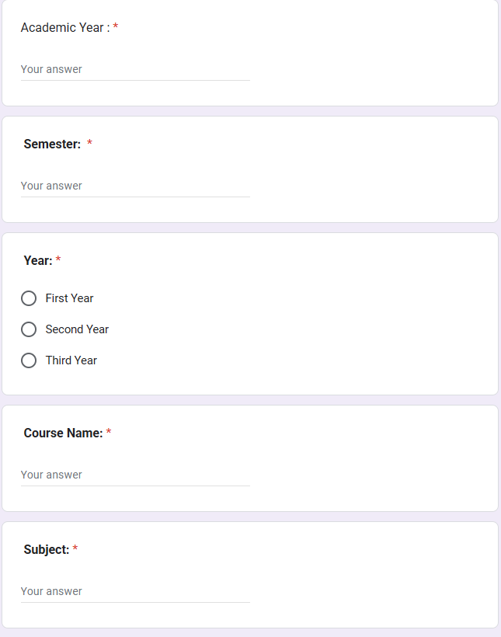

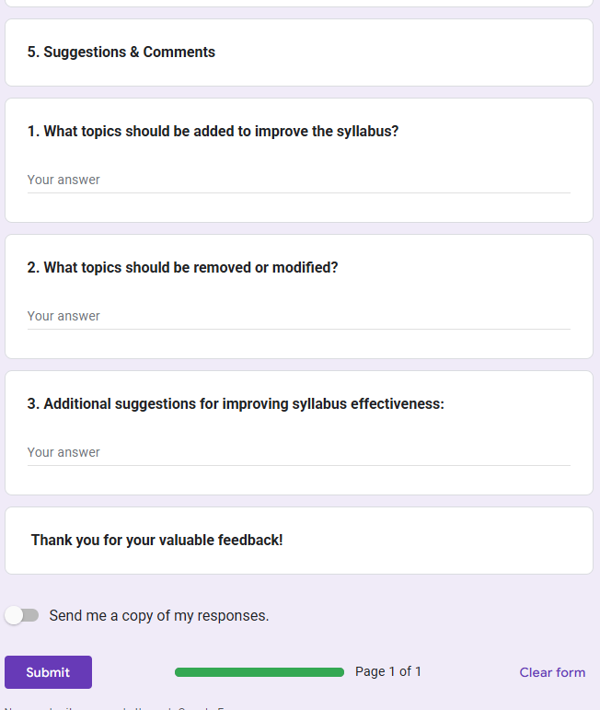

6.Indirect Co Attainment

COs | Indirect attainment  %
CO1 | 100
CO2 | 87.5
CO3 | 91.66
CO4 | 100
CO5 | 100

7.Summary of PO/PSO Attainment

Attainment Level
Below 35 | NO attainment
35-49 | 1
50-59 | 2
60 &Above | 3

PO1
Combined Attainment 0f PO1
Direct  attainment | Indirect  attainment | Combined  attainment | Attainment  Level
72.63 | 95.83 | 83.62 | 3

PO1 Attainment Gap
Combined attainment | 83.62
Target | 80
Attainment Gap | 0
Conclusion | Target attained

IQAC Principal

